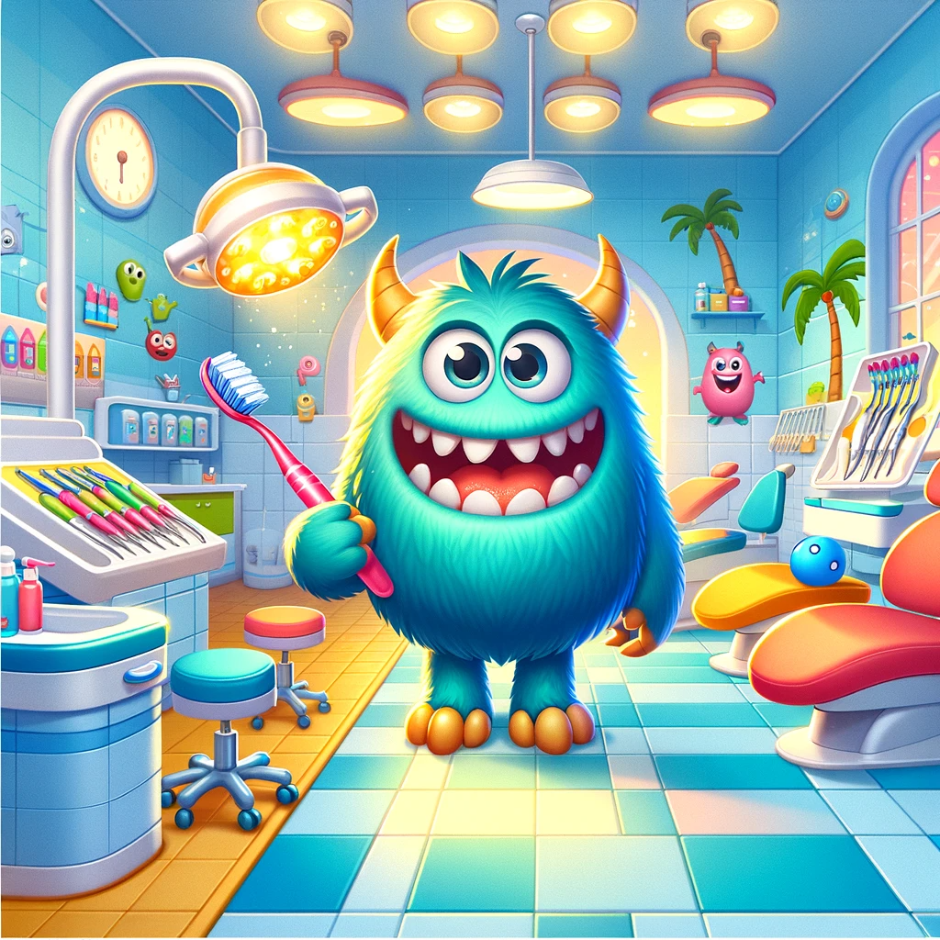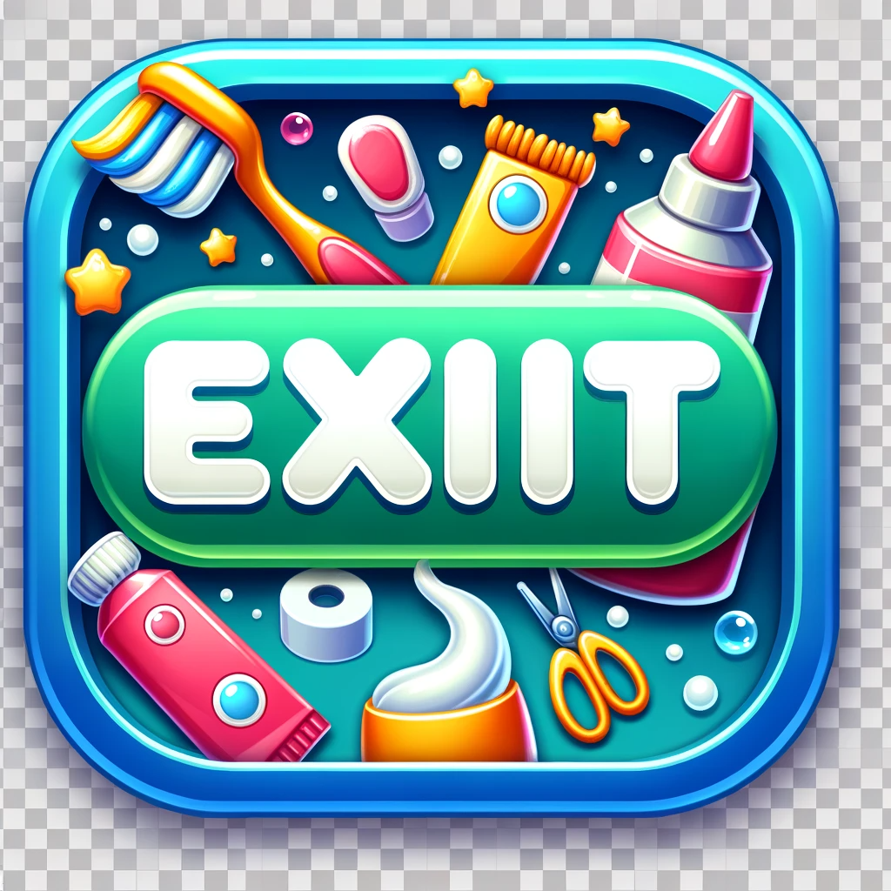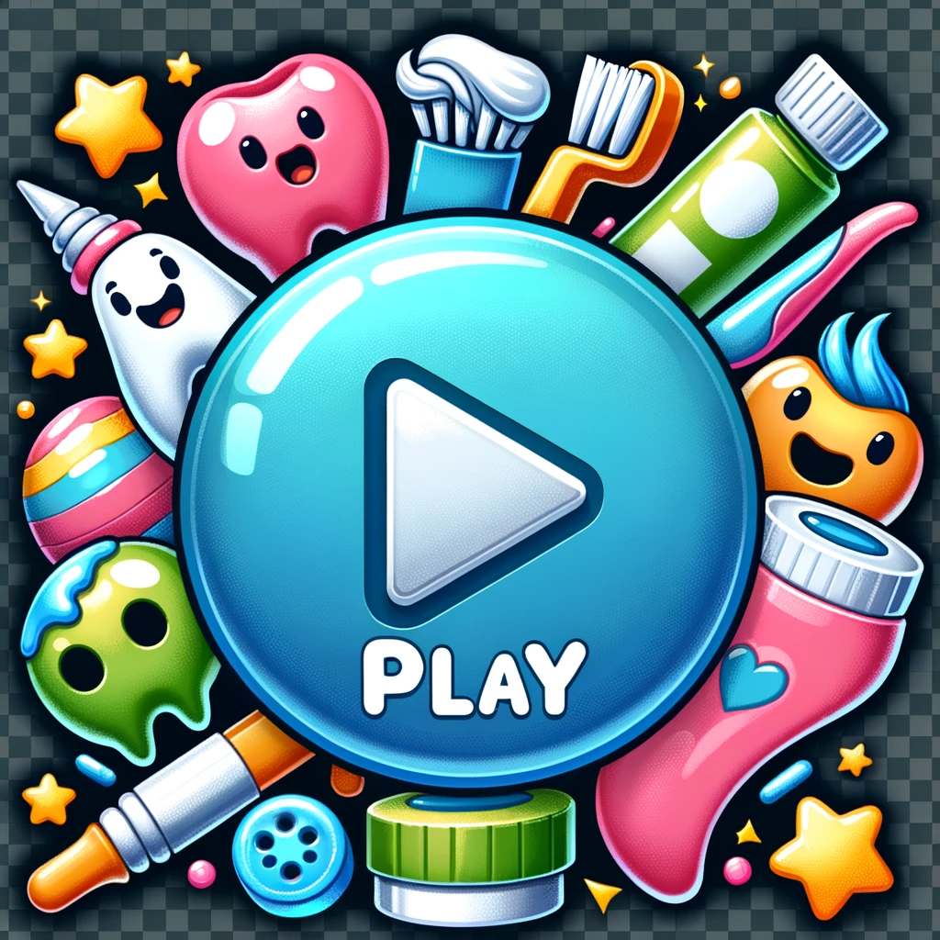

Place the sentence at the top to choose the number of players.

Write a beautiful sentence.

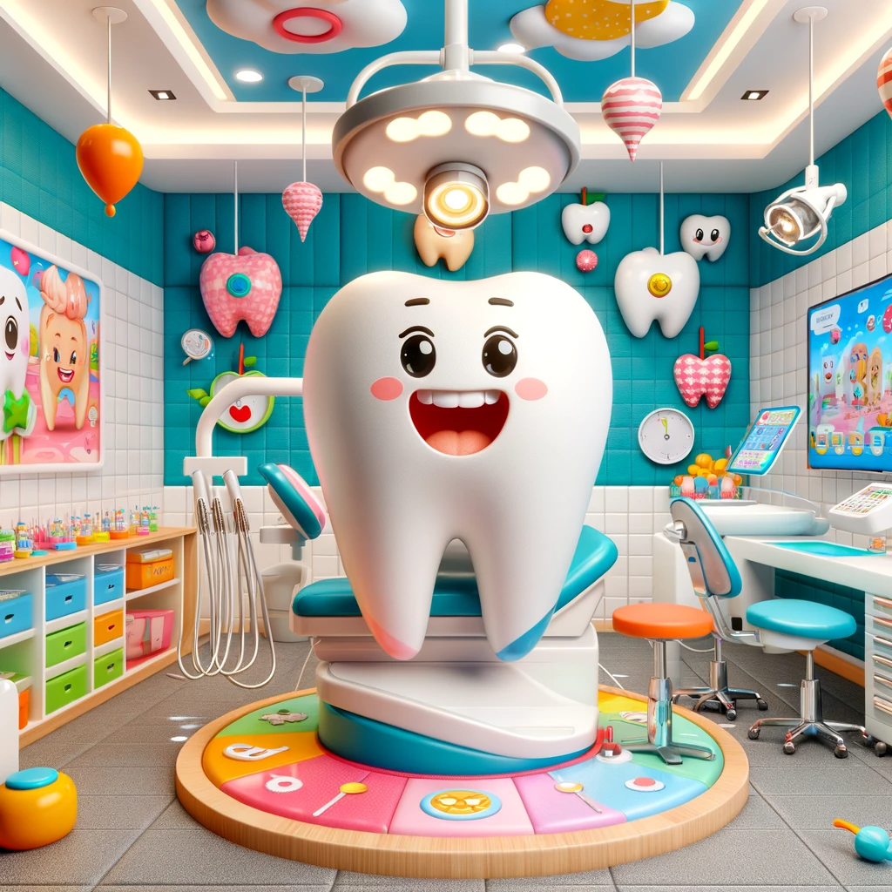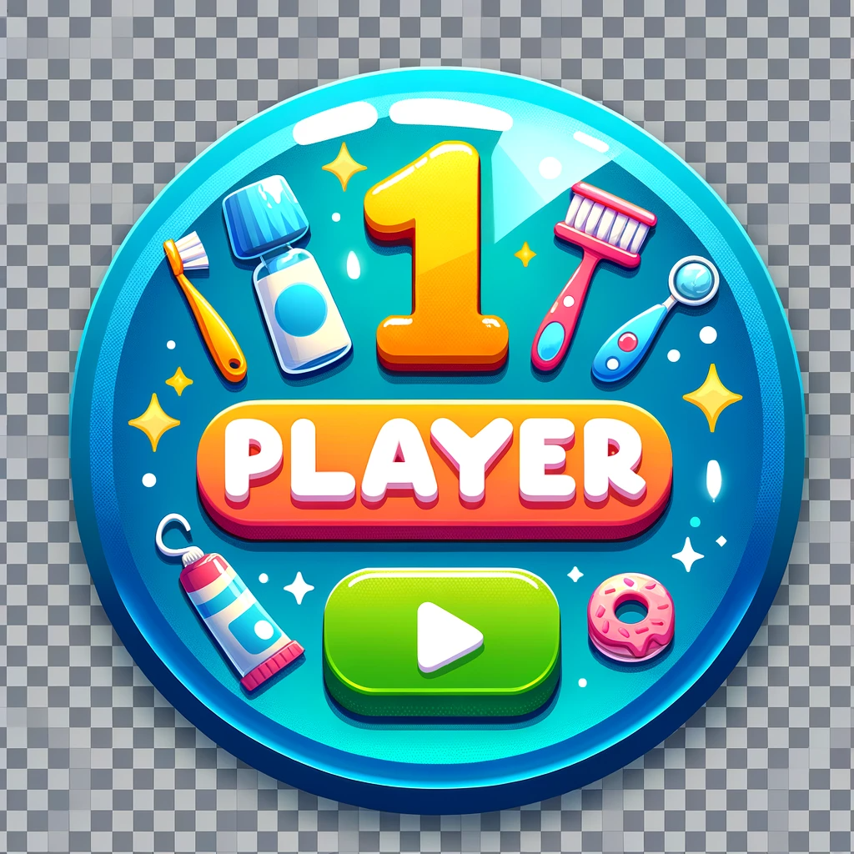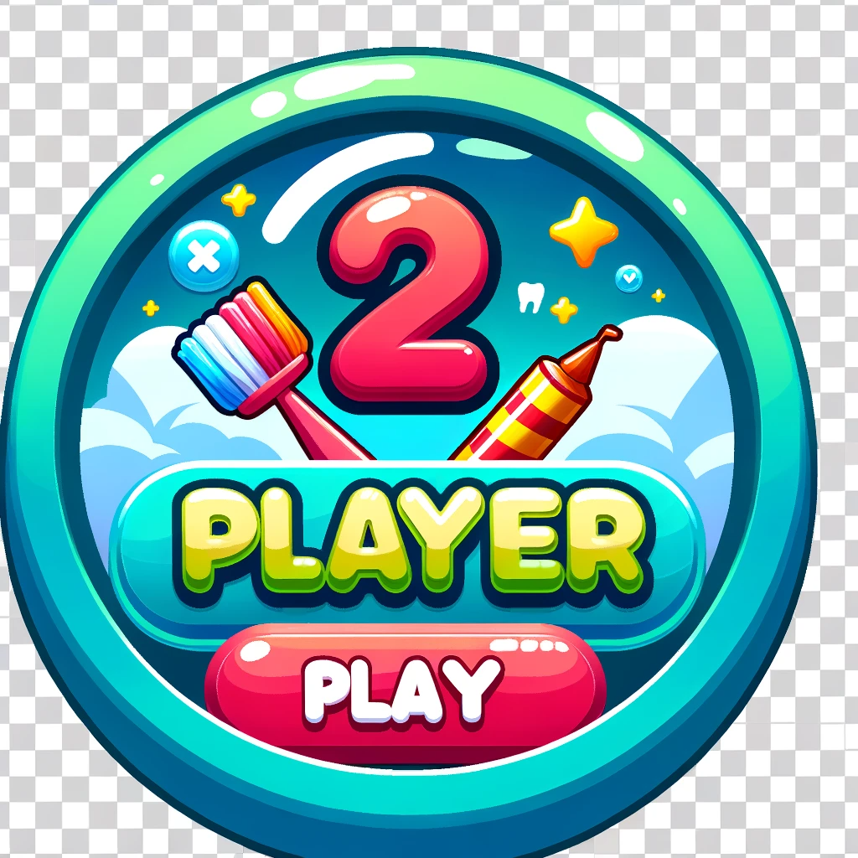

Place a nice phrase 'Choose your playtime' at the top of the image

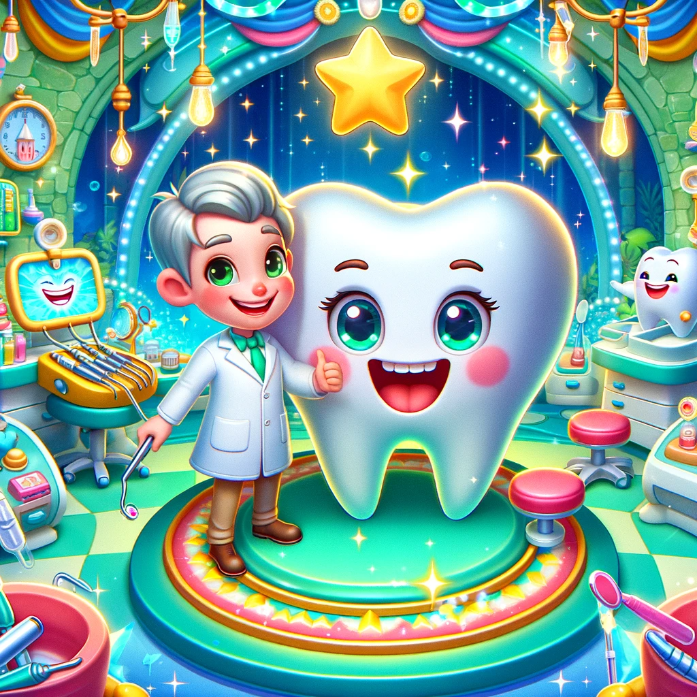  
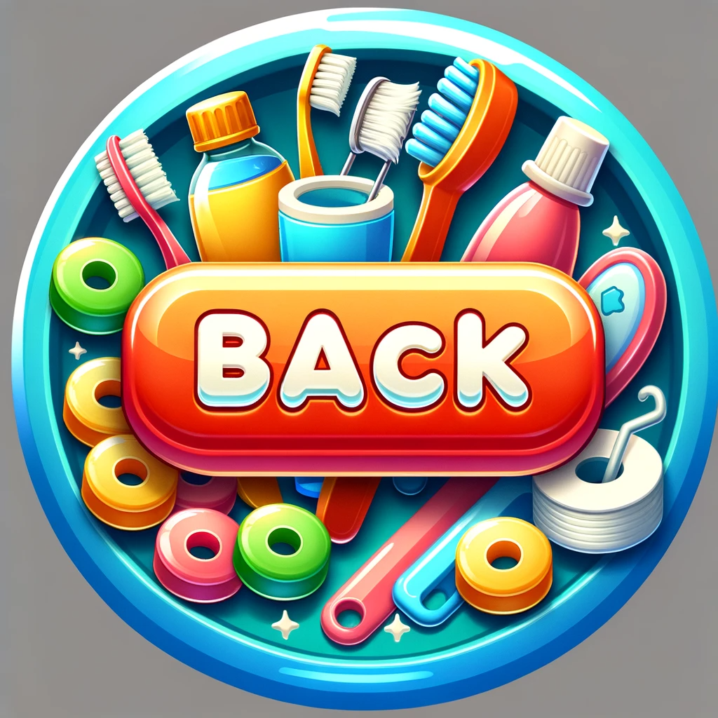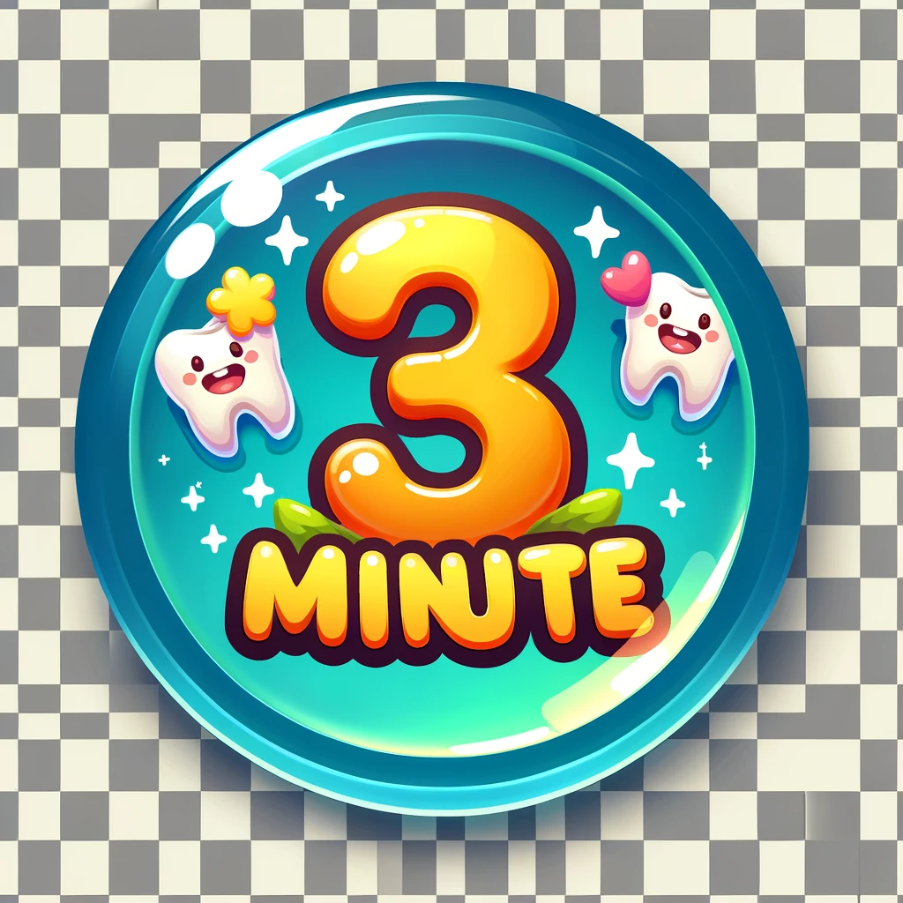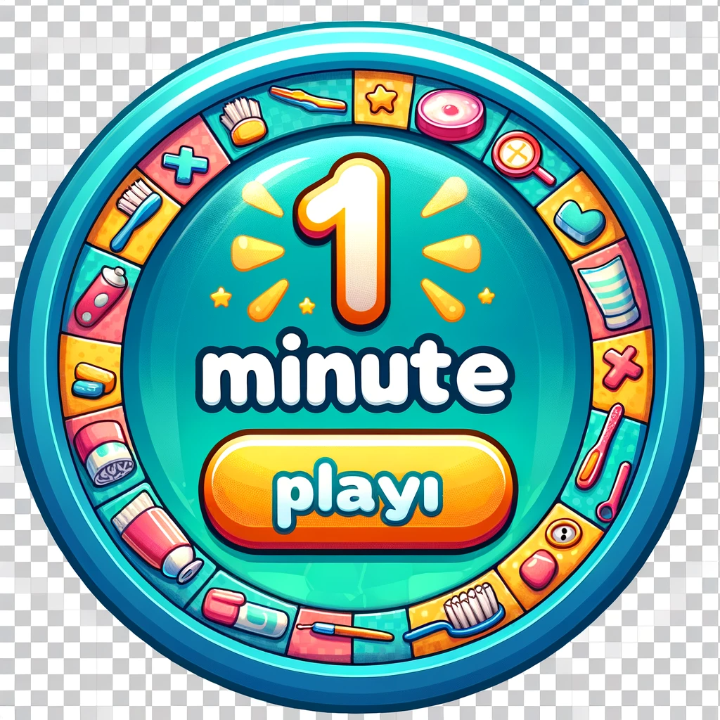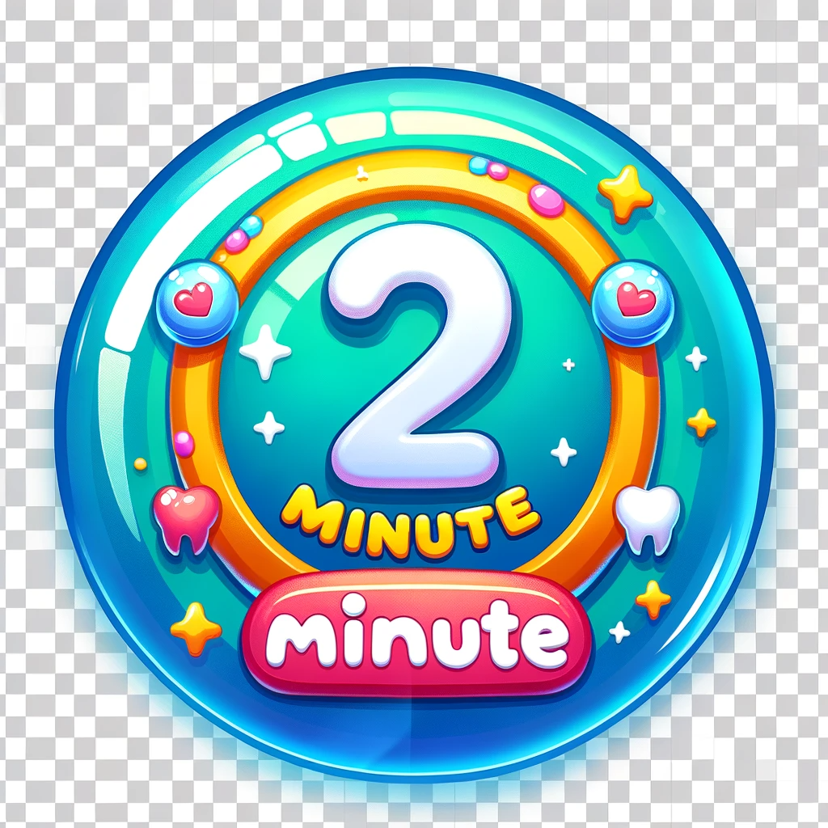

Add a score timer.Players have to click on candies, cakes, lollipops, and microbes to destroy them so that the monster doesn't eat them and gets dirty teeth. Create an animation when these items touch the monster's teeth, like a stain or something similar. At the end of the game, display the score, wait for 4 seconds, and show our company's animation. Then, return to the initial screen.

Here's the translation in English:"When we destroy something, there's a nice animation. The monster is located at the bottom of the screen. We get 2 points each time we destroy a microbe. Display the scores prominently and show a nice '+2' every time we earn 5 points from destroying microbes.

Divide the screen into two halves in an attractive way for the two players.

The cakes, candies, lollipops, and microbes fall from the bottom to the top, from left to right. Players must destroy them, and if they stay in the monster's mouth for more than 5 seconds, they lose 1 point, and it creates a stain on the monster's teeth and on the candy or microbe. (If possible, have the candy or cake be eaten by the monster; if not possible, just leave a stain on the teeth.) Add many things that fall.  
  
Attention, we are working on an interactive game. Ensure that the visuals appear as low as possible on the screen, along with the monster. They can move up and down on the sides so that every child can easily tap on the visuals. Make the visuals large enough.

